
PASTORS & EDUCATORS Shared Session Wednesday afternoon
The Trinity of Vocation: A Path Toward Security in Ministry
Vocation is a key doctrine of the Lutheran Church. It is the daily call from God to love and serve our neighbor in the ordinary roles of life. In this presentation Rev. Dr. Justin Hannemann will provide theological and practical insight into how Vocation helps promote security in ministry. Insecurities in leaders result in struggles with relationships…with conflict…with vision…with the soul care of those they serve. The security we have been given through the Cross of Christ and the calling to love our neighbor in our daily work lays a foundation for healthy minds, hearts, and relationships in ministry.
Rev. Dr. Justin Hanneman
Justin, his wife Katherine, and their four children live in Seward, Nebraska. Justin is the Cofounder and CEO of GracePoint Institute for Relational Health. GracePoint is a counseling and consultation ministry with offices in Lincoln and Omaha. He is also Executive Assistant to the Nebraska District-LCMS President, with a special emphasis on Ministerial Health. He has earned an MDiv from Concordia Seminary in St. Louis and a PhD from Saint Louis University’s School of Medicine. He is a Licensed Independent Mental Health Practitioner and Licensed Marriage and Family Therapist in the State of Nebraska. Justin has a passion for helping people develop and maintain healthy relationships in the name of Christ. You can find more information about Justin and GracePoint at www.relationalhealth.org

PASTOR SESSIONS

The Office and Vocation of the Lutheran Pastor—Past and Present
with Rev. Dr. Rick Serina
Being a pastor is never easy, but it is especially challenging to be a Lutheran pastor in an American context that is so often at odds with us theologically and socially. We’ve long had tensions synodically over authority in the church, the relationship between clergy and laity, and the role of ordination. We continue to have internal debates over routes to ministry and the qualification of candidates for the office, when many other churches educate their pastors far less and expect even less of them theologically. We have uncertainties about the long-term viability of our congregations, our own livelihoods, and the unity of our church body, all while facing constant cultural headwinds on moral issues that complicate our efforts to teach the biblical faith and reach unbelievers. Taken together, that can make for a tough time to serve the church pastorally—but it may also be the perfect time to do so. Against this backdrop, how should we understand the role and responsibilities of a pastor—Scripturally and historically, in the Missouri Synod, and in this cultural moment? In our three sessions, we will explore these and other questions as they relate to historical Lutheran understandings of the pastoral office and ministry, Scriptural and confessionals parameters for the pastoral office and ministry, and the practical challenges and opportunities of pastoral ministry today.

Session 1: Office and Vocation of the Pastor: Historical Complexities
This session will examine the basic definitions and distinctions Lutherans have historically made concerning the pastoral office and how they correspond to debates and positions taken by Luther, the Lutheran Confessions, and our Missouri Synod forebearers.

Session 2: Office and Vocation of the Pastor: Theological Principles
This session will look at the foundational Scriptural and confessional principles of the Lutheran view of the ministry, the church, and the pastoral office, utilizing the 2024 CTCR document, Mission and Ministry Principles and Practical Observations and Suggestions.
Session 3: Office and Vocation of the Pastor: Practical Realities
This session will move on to the challenges—social and cultural, theological and denominational, fiscal and political—facing Lutheran pastoral ministry today, beginning with the same 2024 CTCR document as a starting point before tackling other unique challenges confronting us in the present.
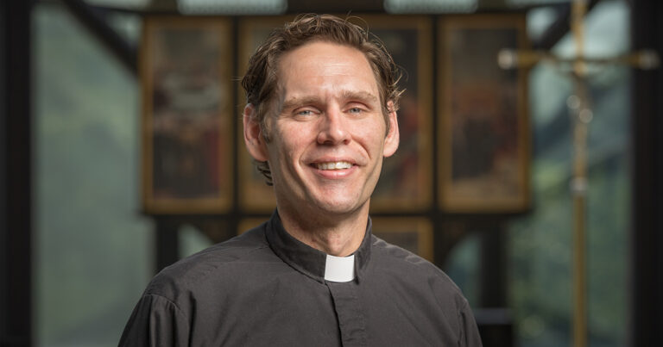
Rev. Dr. Richard J. Serina, Jr., is Associate Executive Director of the Commission on Theology and Church Relations. Prior to joining the staff of the CTCR, he served for more than a decade as parish pastor in rural West Texas and suburban New Jersey, and he has taught at Concordia Seminary, St. Louis, and Concordia College, Bronxville. He received his PhD in Reformation Studies from Concordia Seminary and has published multiple books and essays dealing with the theology and history of the late Middle Ages and the Reformation. In his work with the CTCR, he is specially focused on ecclesiology, church polity, and how the church navigates the emerging theological, ecumenical, technological, political, and ethical challenges of the present day. He lives in St. Louis with his wife, Christina, and six children.

EDUCATOR SESSIONS
Thursday morning
Rev. Dr. Justin Hanneman - The Developing Mind in the Digital Age
We have all seen firsthand that the world is changing. What impact is the digital age having on our students’ minds, bodies, intellects, and social/emotional development? In this presentation Rev. Dr. Justin Hannemann will provide insight into how these young minds are developing in the digital age and that the impact it is having on their faith formation as well as family and peer relationships. There will be some practical discussion about how we, as educators, can amplify the positive and mitigate the negative effects of the digital age on the developing minds under our care.
Thursday late morning
Rev. Bil Hood - The Genesis of Creativity
Creativity is often treated as something reserved for artists, musicians, writers, or unusually imaginative people. But Genesis begins with a far bigger claim: “In the beginning, God created.” And if we are made in the image of God, then creativity is not optional or ornamental. It is part of our human design. In this session, Bil Hood will draw from his book The Genesis of Creativity to explore how Genesis 1 gives us a practical and faithful pattern for creative life and work. Together, we will consider how creativity shows up in the classroom, not only through art or music, but through lesson planning, problem-solving, classroom culture, student engagement, collaboration, and faithful imagination.


Rev. Bil Hood
Bil Hood is the author of The Genesis of Creativity and serves as Senior Director of External Relations and Special Events at Concordia University Irvine, where his work brings together storytelling, donor engagement, media, events, and mission-centered leadership. Bil has spent more than three decades working at the intersection of creativity, communication, and community building. His experience includes producing national PBS programming, directing large-scale events, helping lead major fundraising and engagement initiatives, and working with organizations including Disney, Microsoft, Nintendo, Starbucks, universities, nonprofits, churches, and schools. He is also an ordained pastor in the Lutheran Church, bringing a theological and practical lens to questions of creativity, vocation, and faithful service. Through his writing and speaking, Bil helps people recognize creativity not as a rare gift reserved for artists, but as a God-given capacity woven into what it means to be made in the image of the Creator.
Thursday late morning
Friday morning
Sarah Salzberg— Built Up for Others

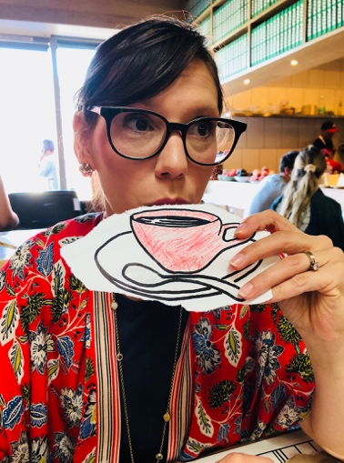
Throughout his letter, Peter uses the language of the tabernacle and the covenant to remind people that God dwells with us and He is for us. It is easy to make that sound like He’s done working, but His work is active; you are being built up! God dwells with us and calls us to dwell with others. God is for us so we can be for others. You have been called to bring God’s presence into your classroom and community and the good news is, Christ is the One doing all the real work!

Sarah Salzberg
Sarah Salzberg lives in Los Angeles, CA with her husband (Josh), son (Hosea) and daughter (Simone), traveling from one coffee shop to another trying as many cappuccinos and croissants as she can. When not hopped up on espresso, Sarah teaches Old Testament at Orange Lutheran High School in Orange County, CA. In addition, she has served as a planner and theological advisor for the LCMS Youth Gathering as well as a speaker for youth and women's retreats around the country. She earned her Masters in Theology from Concordia University in Irvine, but her pride and joy will always be Concordia Seward where she earned her Bachelors in Education. Any opportunity she gets, she loves to share how bananas it is that the God of the universe would choose to limit Himself to human language and the human experience!

Pastor’s Wives Event – Thursday Evening
Presenter: Liane Henkell
Liane is a pastor’s wife, a 20 year veteran of teaching in Lutheran schools, a writer and a passionate church leader. Liane works with Garuna, a ministry bringing the Good News of Jesus to Southeast Asia developing chapel & VBS materials for U.S. churches and schools, which includes scripted curriculum, videos, and much more! She is also involved in the redesigning of the coursework for LISA students and teachers.
Liane and her husband Jim currently reside in Chandler, Arizona, where Jim serves as the Ministry Executive for the Pacific Southwest District of the LCMS. They share one granddaughter, three adult children here on earth, and one child in heaven. Liane recently published a devotional book titled, "The Toilet on the Sidewalk: Finding Hope in Christ through Unexpected Circumstances."

